**Data collection and extraction**

**Collect the Dataset:**

**Step 1:**

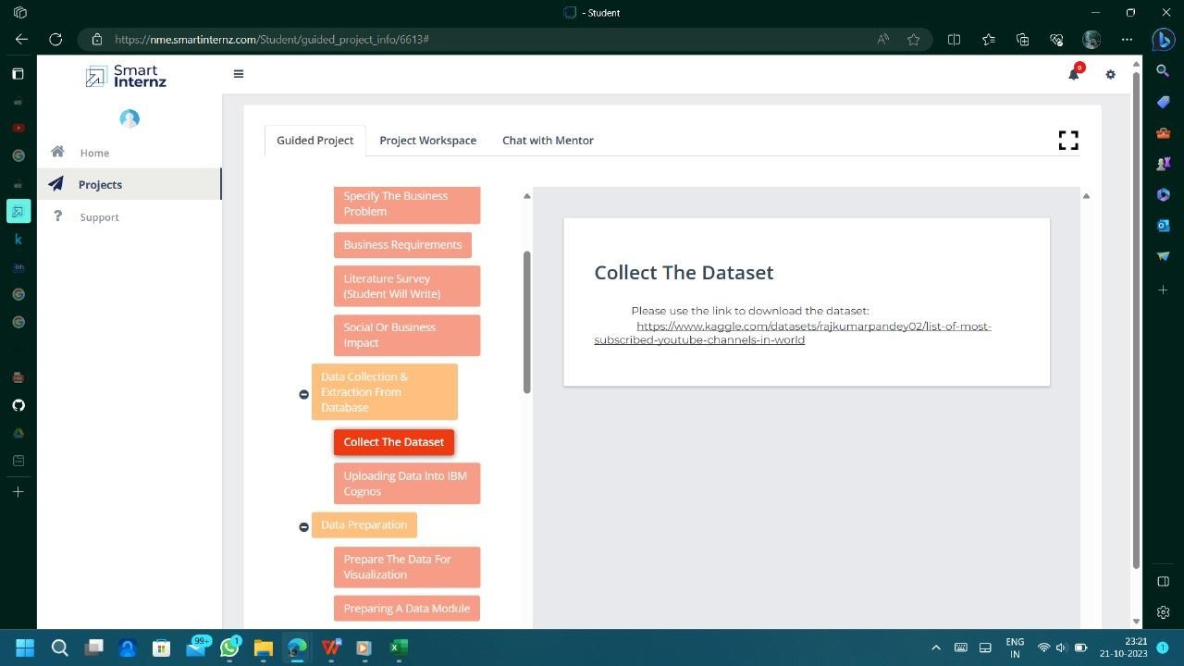

**Step 2:**

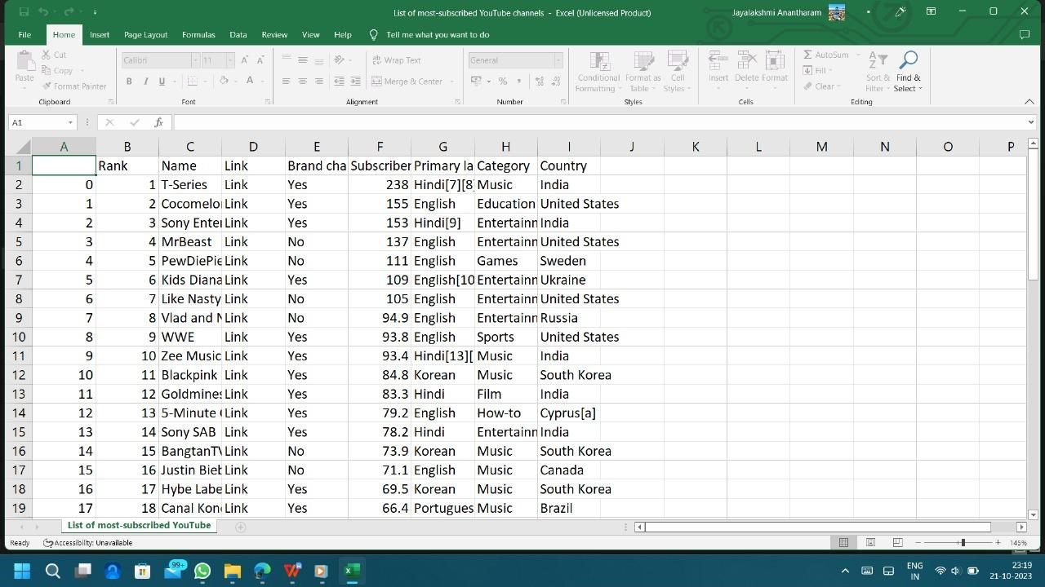[**https://www.kaggle.com/datasets/rajkumarpandey02/list-of-most-su**](https://www.kaggle.com/datasets/rajkumarpandey02/list-of-most-subscribed-youtube-channels-in-world) **bscribed-youtube-channels-in-world**

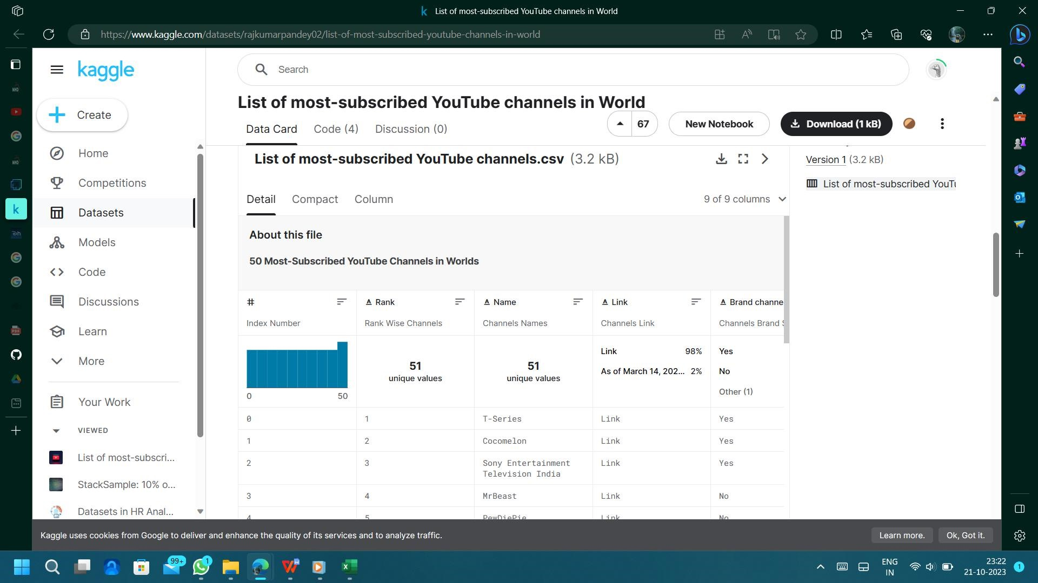

**Step3:**

**Uploading the data in IBM Cognos:**

